Q1.
A: double total = 0;
for (int i = 0; i < prices.length; i++) {
total += prices[i] * quantities[i];
}
return total;
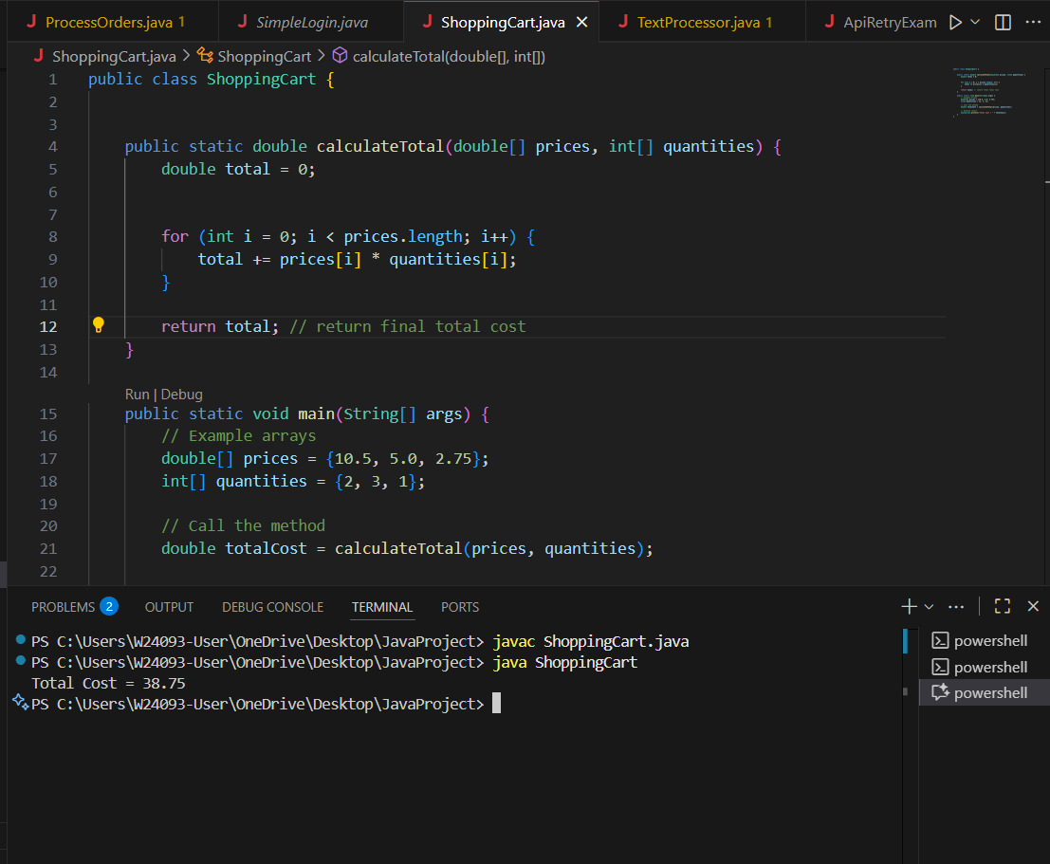

A: Uses correct data type; double total
Uses correct formula; price * quantity
Uses correct loop; iterates through all items

B: total is declared as int, but prices[i] is a double.

C: This loop adds only prices, ignoring quantities.

D: It adds price + quantity instead of multiplying them. This gives meaningless results.

Q2.
- (num % 2 == 0) && (num % 3 == 0) && !(num % 5 == 0)
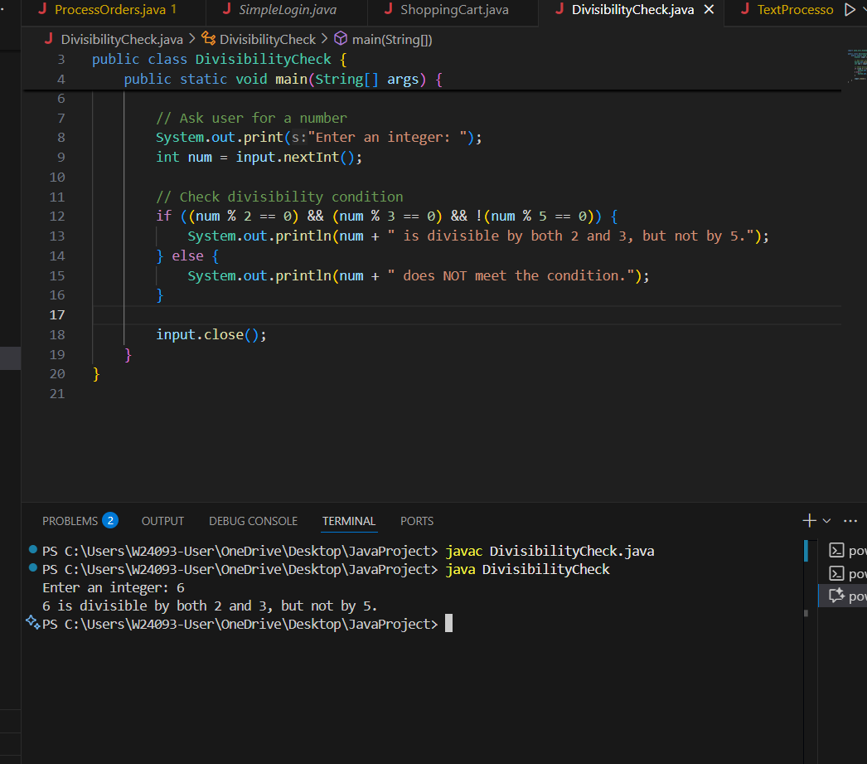

A and D are both logically correct,
but Option A is the simplest and most readable form.

B and C are Incorrect due to wrong logical grouping.

Q3.
B. int max = arr[0];
for (int i = 1; i < arr.length; i++) {
if (arr[i] > max) max = arr[i];
}
return max;
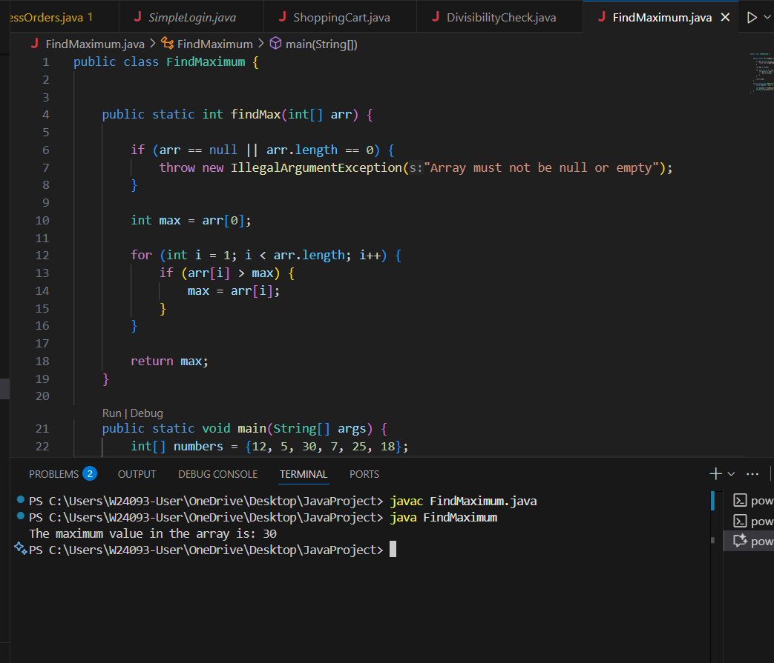

Q4.
B: B. s.charAt(i) == s.charAt(s.length() - i - 1)
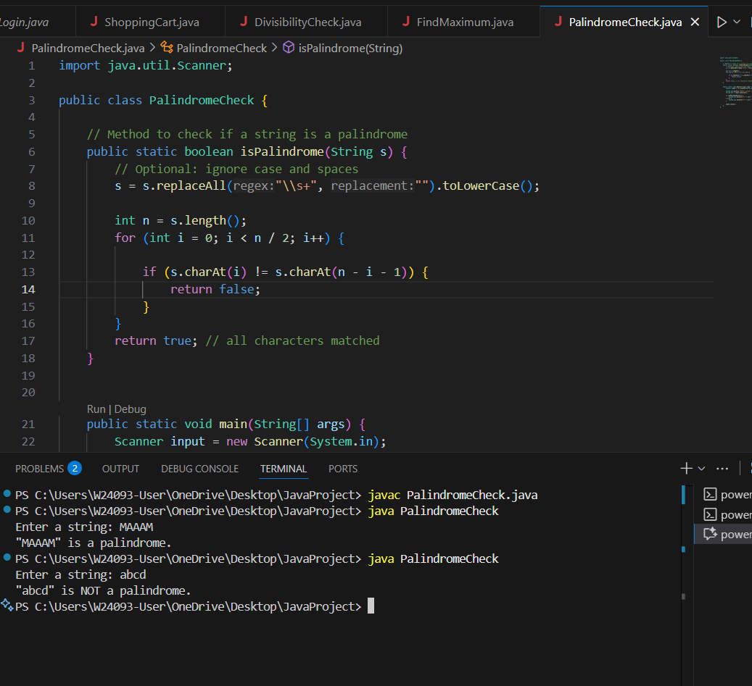

A: Uses s.length() - i → out-of-bounds.

B: Correct opposite-end comparison using s.length() - i - 1

C: Same as B, just different notation

D: Off-by-one shift; mismatches characters

Q5.
B: . int mid = low + (high - low) / 2;
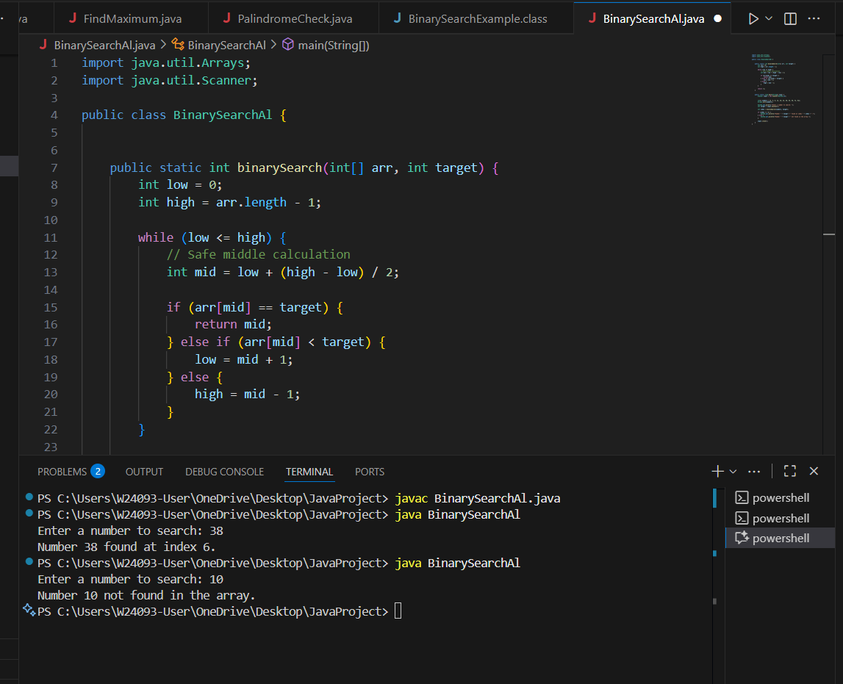

Q6.
- (year % 4 == 0) && ((year % 100 != 0) || (year % 400 == 0))
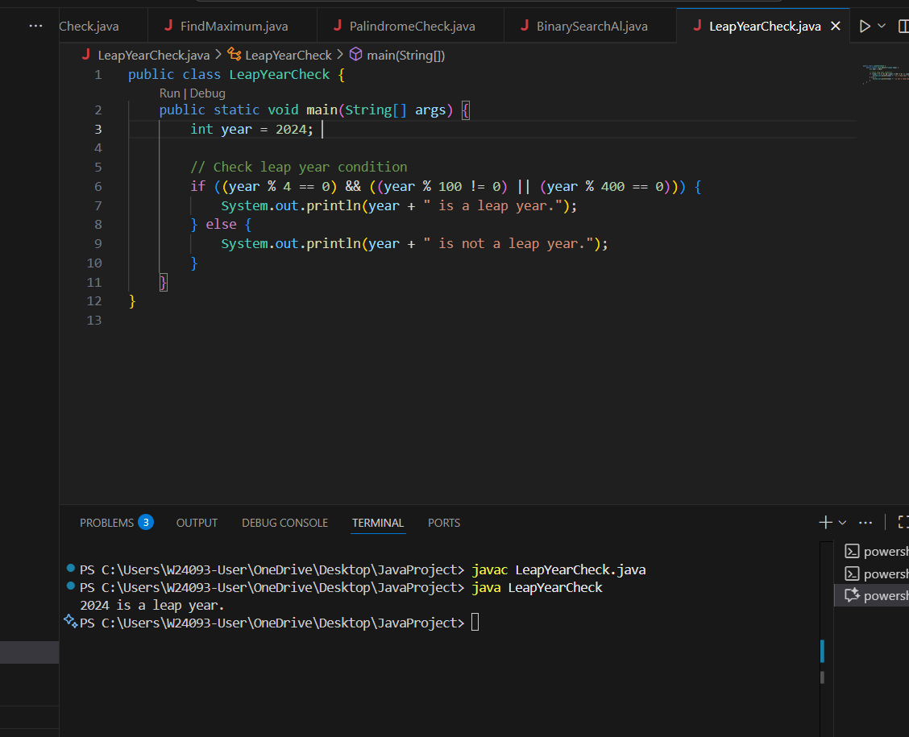

A: is logically equivalent to B, but not group rule properly.

B: divisible by 4 and then not divisible by 100 or divisible by 400 is that match exactly.

C: return true for any year divisible by 4 is leap year (so 1900 as leap years) that’s wrong

D: requires divisible by 4 and 100 and 400, i.e. only multiples of 400.

Q7.
A. String prefix = strs[0]; for (int i = 1; i < strs.length; i++) { while (strs[i].indexOf(prefix) != 0) { prefix = prefix.substring(0, prefix.length() - 1); if (prefix.isEmpty()) return ""; } }
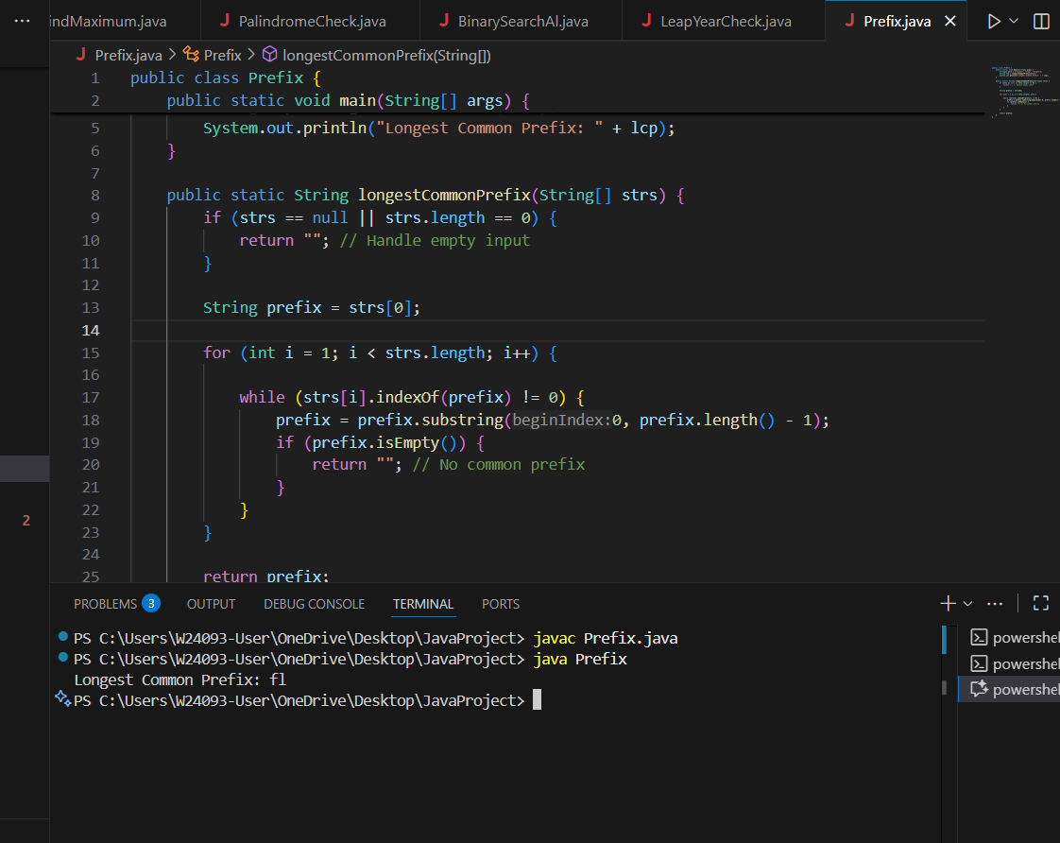

A: can find a exact longest common prefix.

B: Sorting guarantees that the first and last strings will reveal the maximum mismatch.

C: Directly checks each character of all strings; guarantees the LCP.

D: Less efficient than A/B/C due to multiple iterations and stream overhead.

Q8.
B.int maxSum = Integer.MIN_VALUE, currentSum = 0;
for (int num : arr) {
currentSum = Math.max(num, currentSum + num);
maxSum = Math.max(maxSum, currentSum);
}
return maxSum;
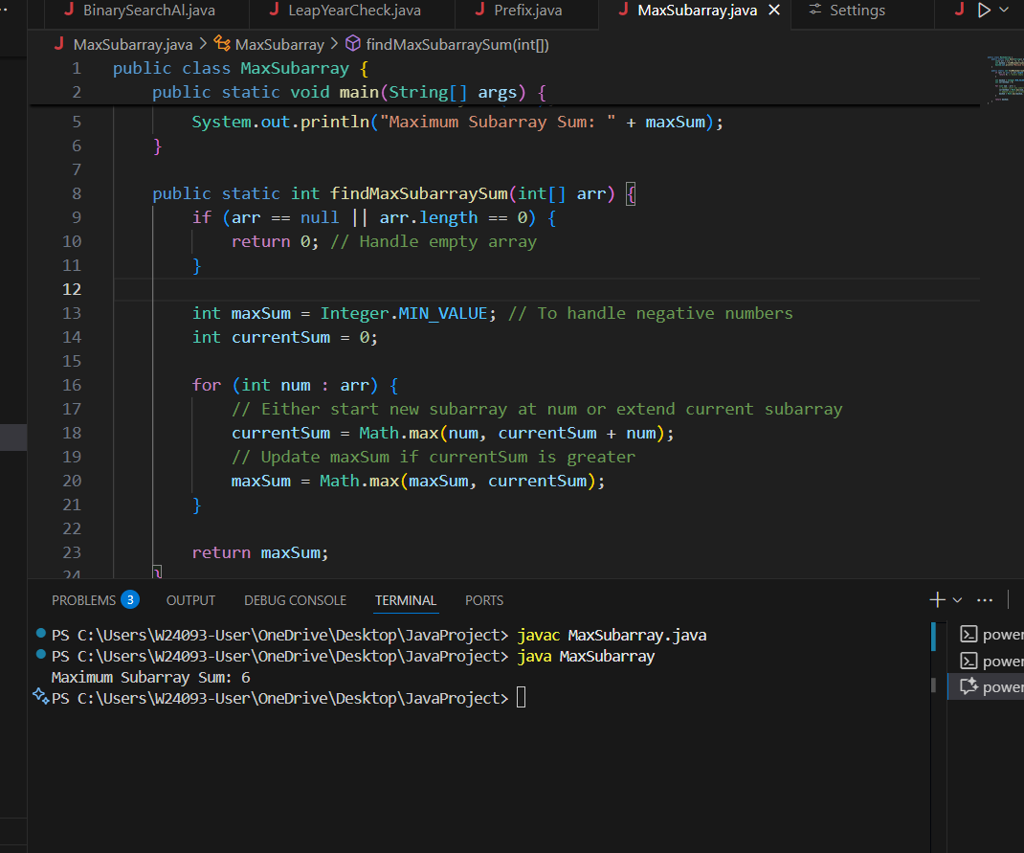

This implementation is correct because it efficiently tracks the maximum subarray sum at each step, deciding whether to extend the current subarray or start a new one, and updates the overall maximum. This is exactly how Kadane’s algorithm works.

